Shockwave Therapy

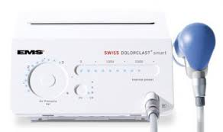
Shock wave therapy, also referred to as Extracorporeal Shock Wave Therapy (ESWT), is a relatively new treatment in the podiatry world, however it has been used for over thirty years in different health areas. Mid Coast Podiatry is excited to bring this therapy to the Mid North Coast, we are the only podiatry clinic currently utilising the Swiss Dolorclast ESWT Shockwave Machine, the industry leader for Shockwave therapy.

There is research evidence supporting the use of shock wave therapy in treating common tendon injuries and studies have found that in some cases it improves treatment outcomes in Achilles tendinopathy over and above exercise only treatment strategies. Shockwave can be a useful treatment for chronic (long-term) plantar fasciitis (heel pain), Achilles tendinosis, gluteal/hamstring tendinopathy. It can also be used as a modality for treating trigger points in muscles, especially useful if you have a needle phobia.
How does it work?
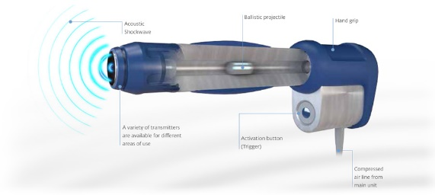
Shockwave was originally developed to treat kidney stones and has been used in this capacity for many years. As technology developed and more research was conducted it was it could be used to treat musculoskeletal and tendon injuries, that have failed to heal spontaneously and have failed to respond to other treatments such as stretching, massage, orthoses, exercises modification and appropriate footwear. High frequency soundwaves are delivered in a non-invasive application through the skin at the injury site and surrounding area. It is thought that the soundwaves stimulate healing by evoking a small inflammatory response, increasing in blood flow and metabolic activity to the injured area, the treatment also decreases pain at the site. Research has found that about approx. 75% of patients have a significant improvement in their pain after shock-wave therapy.
Treatment Process
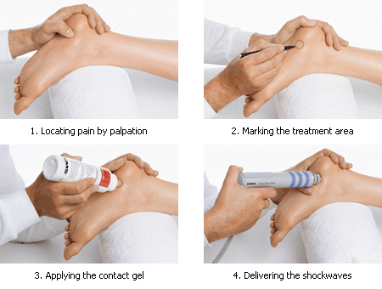
- The treatment session lasts approx. 5 to 10minutes. You may experience a short period of localised discomfort whilst the shockwave is being applied, this goes away quickly.
- Three to five treatments depending on pain response are the standard. Treatments are undertaken once a week and are often combined with stretching/taping/orthotics (if required). Benefits from the shockwave continue for six weeks, follow up at this point is important.

Are there any side effects or contraindications?
- Shock Wave Therapy should not be used if there is a circulation or nerve disorder, infection, bone tumor, or a metabolic bone condition. Shock Wave Therapy should also not be used if there are any open wounds or tumors or if the patient is pregnant. Patients who are on blood-thinning medications, including fish oil supplements or who have severe circulatory disorders may also not be eligible for treatment.
- Upon completion of your treatment you can return to most regular activities almost immediately although it is advised to rest the injured area for the best healing to take place. Discomfort, liked to what is sometimes experienced after a deep tissue massage may persist for a few days following treatment but no serious complications or side effects have been reported.
It is important to note that Shockwave is not usually a standalone treatment modality and other treatments should have been tried. Most injuries are caused by an increase in load (e.g. increase of training too quickly) and in some cases poor biomechanics/weak muscles are also a factor, these must all be taken into account for an injury management plan to be effective. A full biomechanical assessment will be completed at your initial consultation.

For more information or to book an appointment, please call us on 02 6551 4815

